CTEC 305 Project 3 Report

Rosemarie Kpaka

CTEC 305 Server Administration 1

Professor Charles Wolford

November 11, 2024

**Introduction**

For this project, I configured an on-premises identity solution using Active Directory (AD) to centralize management of users, devices, and resources across a simulated infrastructure of six virtual machines (VMs). By setting up Active Directory Domain Services (AD DS) on two designated virtual machines, I provided a robust solution that allows for user authentication, resource sharing, and improved security within the network.

**Environment Setup**

* VM Count: Six virtual machines (VMs)
* Domain Controllers: Two VMs designated as primary (DC01) and secondary (DC02) domain controllers
* Software Used: Windows Server (2022)

**Configuration Steps**

For each of the following steps, screenshots were taken to document successful completion.

***Step 1: Select Two Virtual Machines as Domain Controllers***

I selected two VMs to serve as the domain controllers, named DC01 and DC02. DC01 will be the primary domain controller, while DC02 will act as a backup.

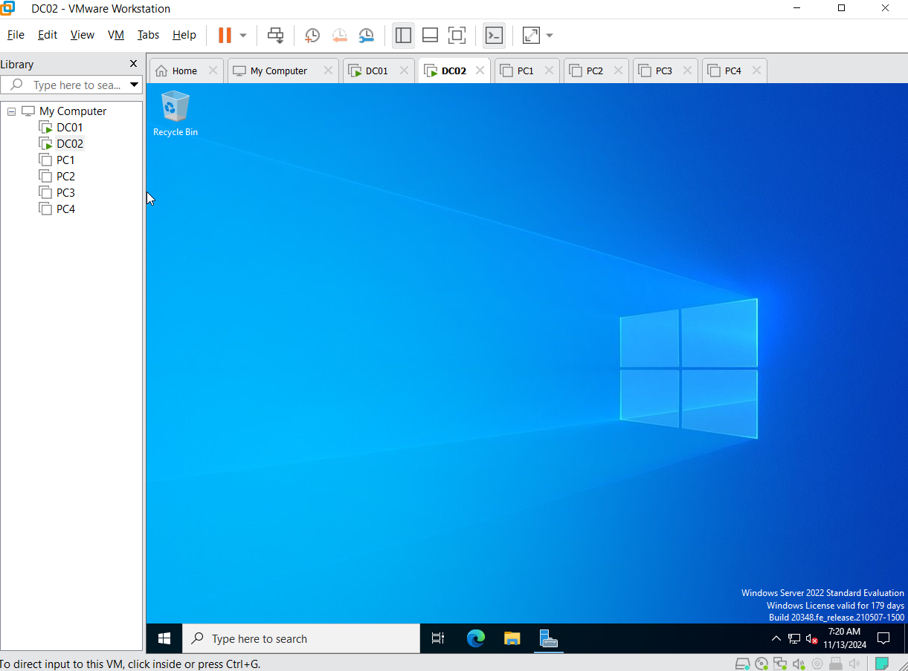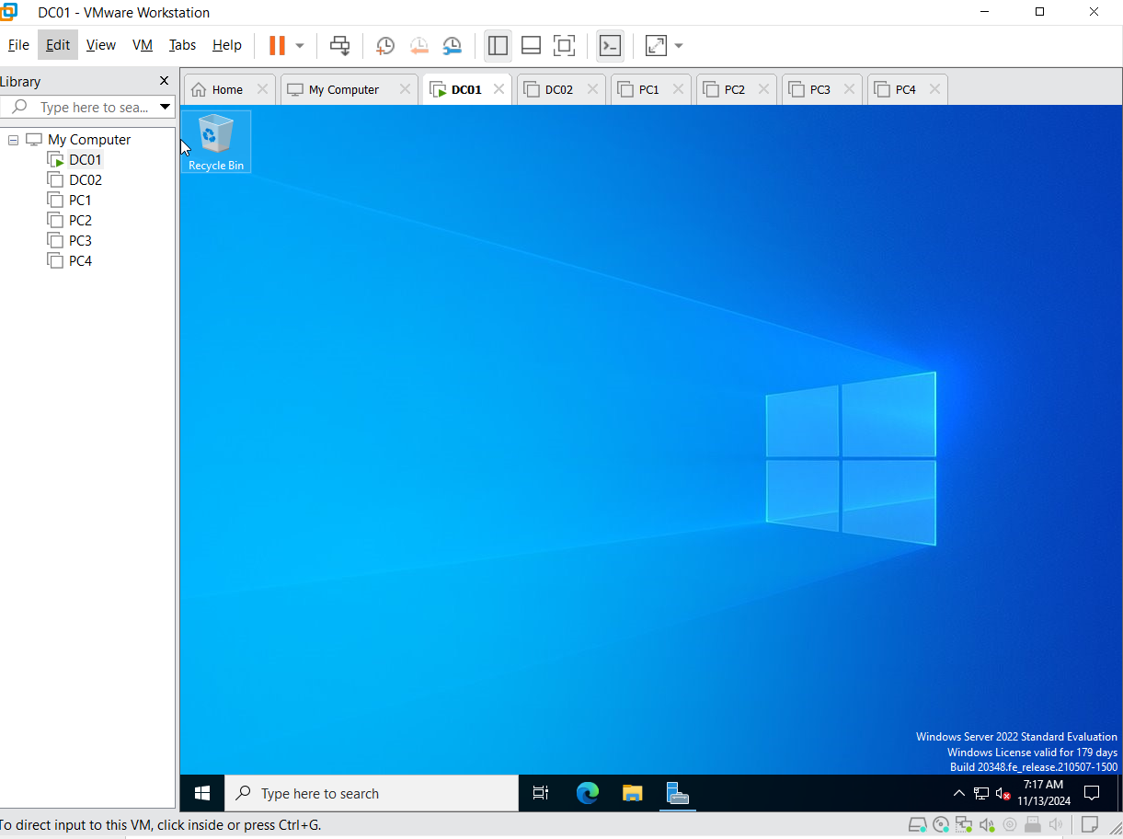

***Step 2: Patch Servers Without GUI***

Using PowerShell, I installed the latest updates for both DC01 and DC02 to secure the servers.

Commands Used:

* Install-Module -Name PSWindowsUpdate -Force -SkipPublisherCheck
* Import-Module PSWindowsUpdate
* Install-WindowsUpdate -AcceptAll -AutoReboot

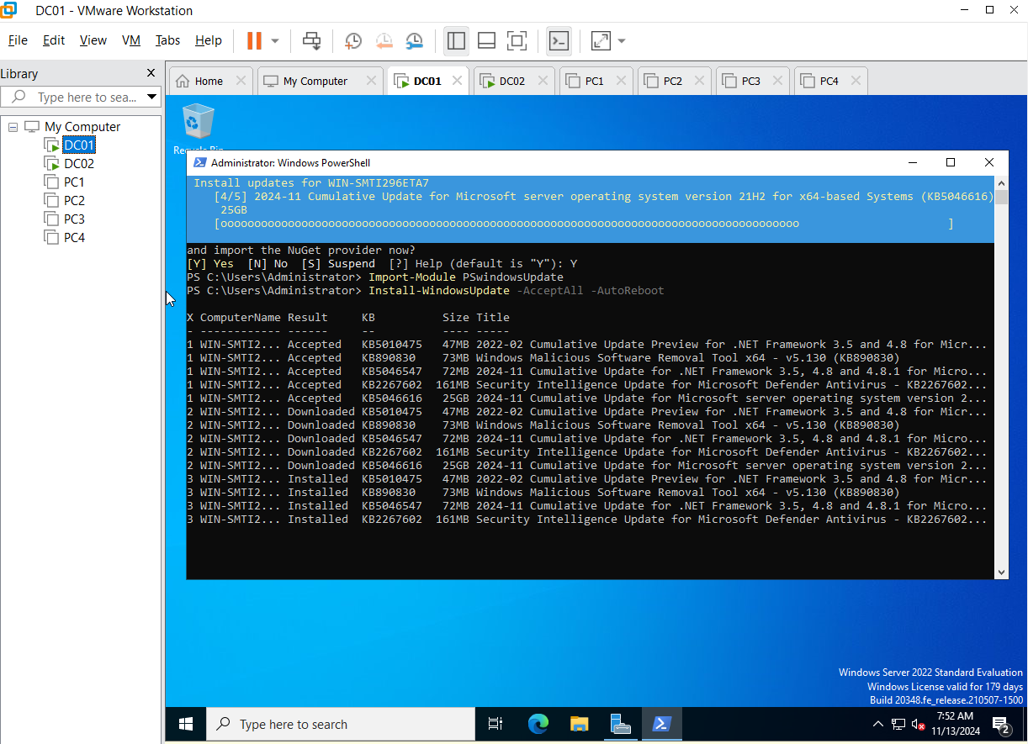

***Step 3: Configure Static IP Addresses***

To ensure network stability, I assigned static IPs to both DC01 and DC02 and configured the DNS settings.

Configuration Details:

* DC01: DNS set to its own IPv4 address.
* DC02: Primary DNS set to DC01’s IP and Secondary DNS set to its own IP.

Commands Used:

* ipconfig /all to view the current IP configuration.

Additional Steps: IPv6 was disabled in the network adapter properties.

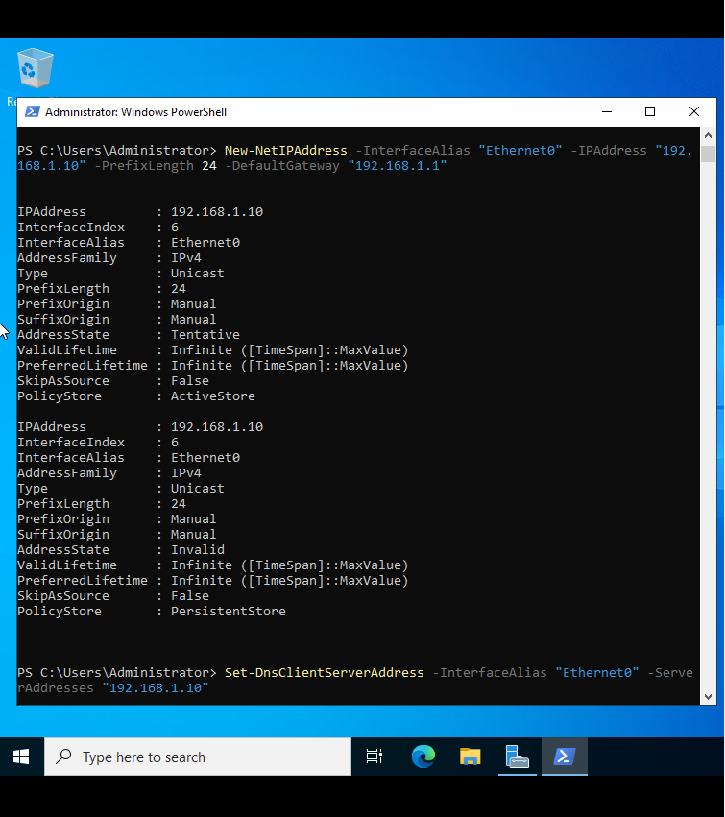

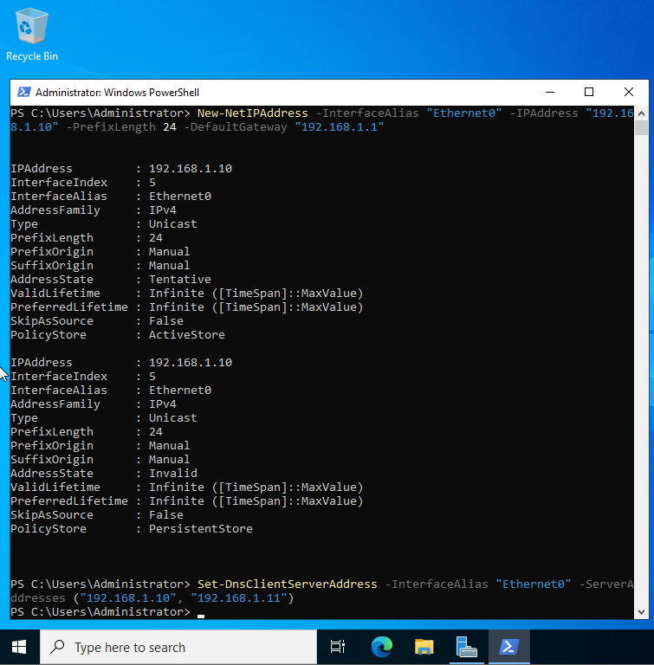

***Step 4: Change Hostnames***

To align with naming conventions, I updated the hostnames:

* DC01: Changed to RKDC01 (using initials)
* DC02: Changed to RKDC02

Commands Used:

* SystemPropertiesComputerName to access Computer Name settings.

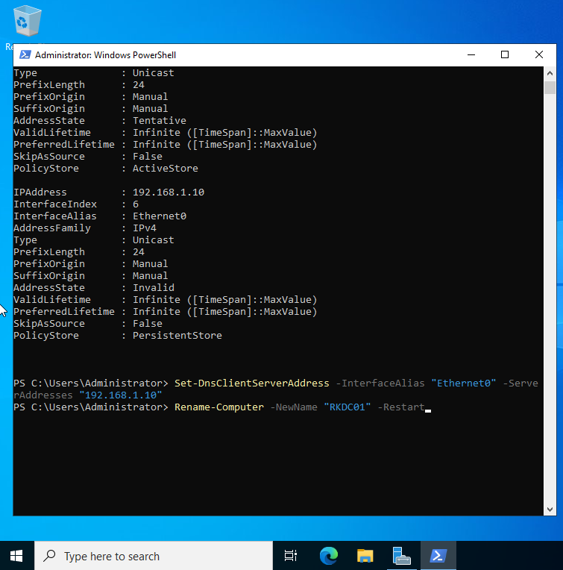

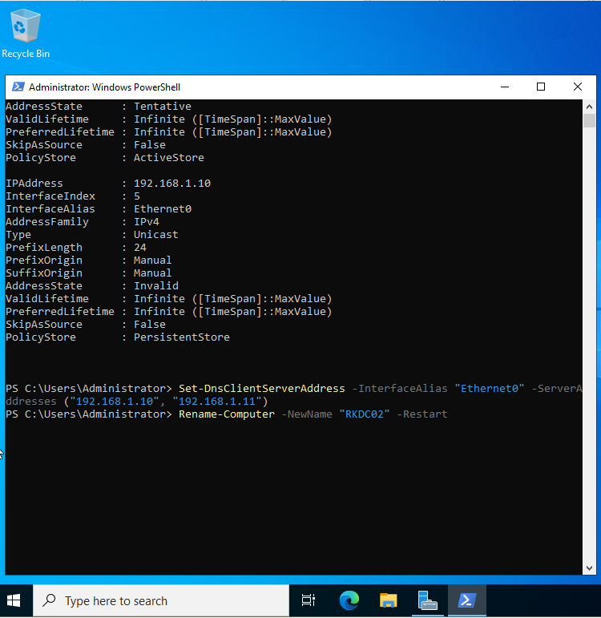

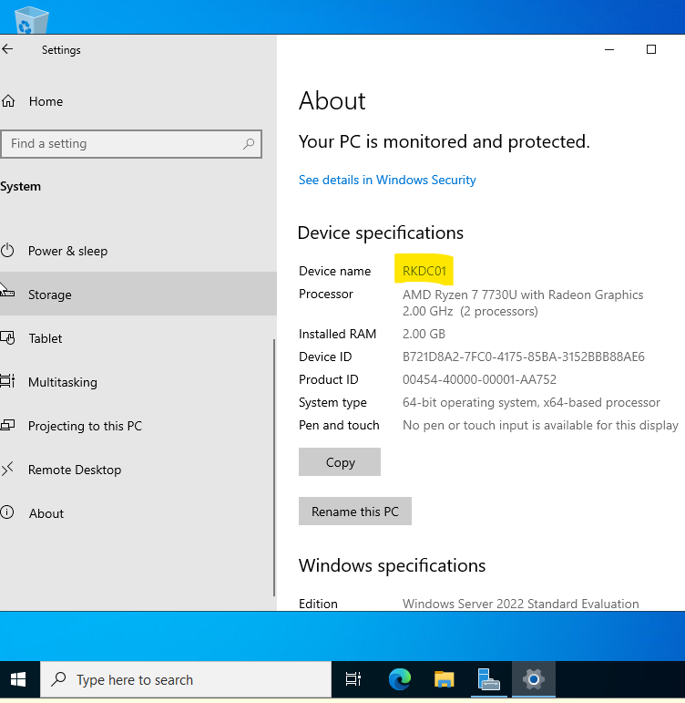

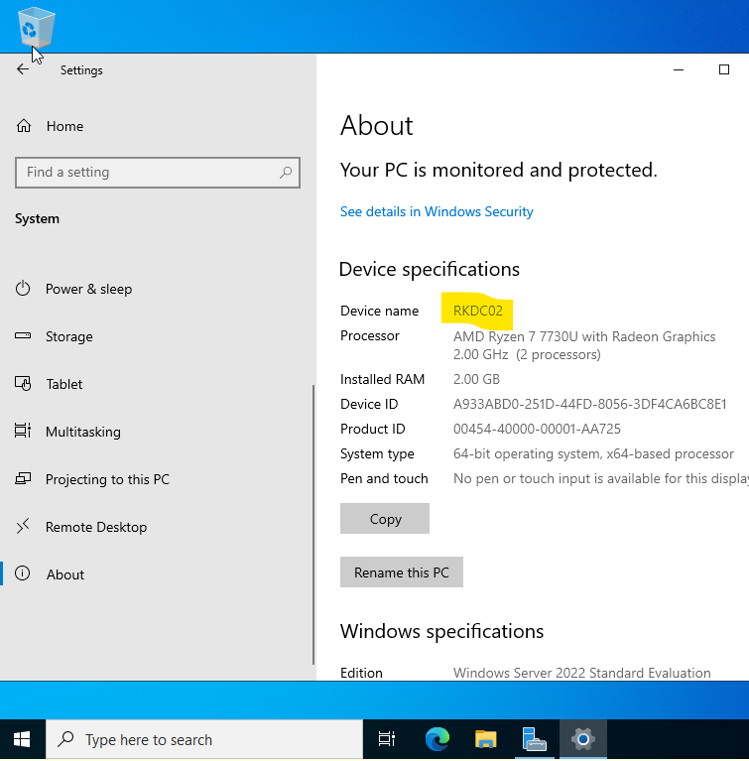

***Step 5: Install AD DS and DNS Roles and Promote to Domain Controller***

To establish a primary domain, I installed AD DS and DNS server roles on both DC01 and DC02.

Configuration Details:

* On DC01: Created a new forest with the domain rkdomain.local.
* Promoted DC02 to a domain controller within the existing domain.

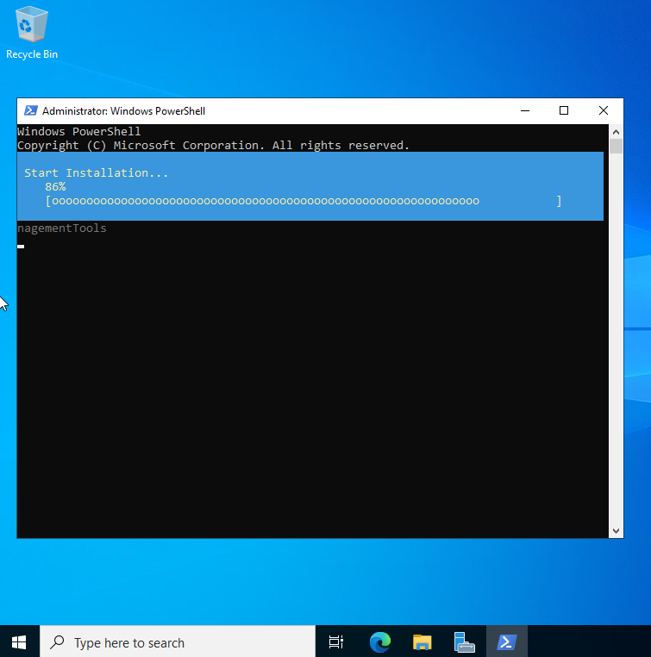

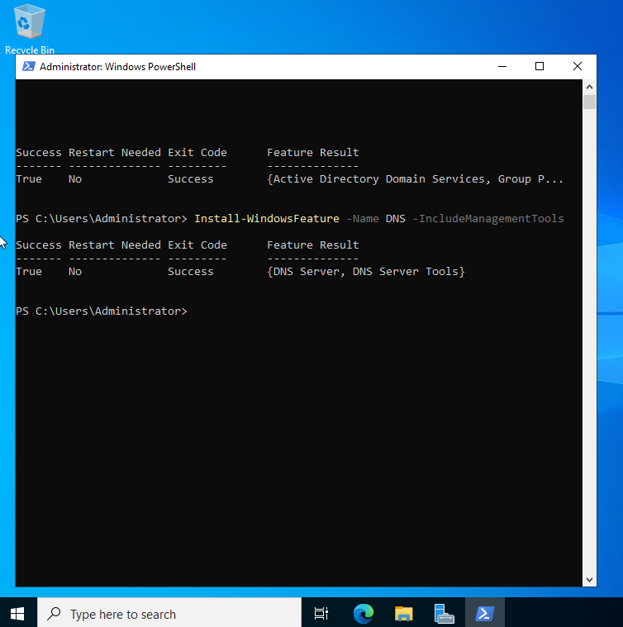

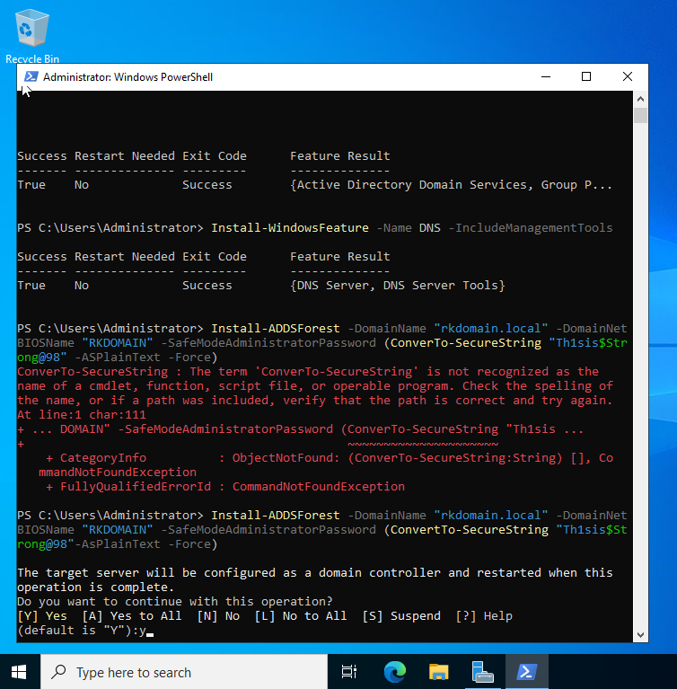

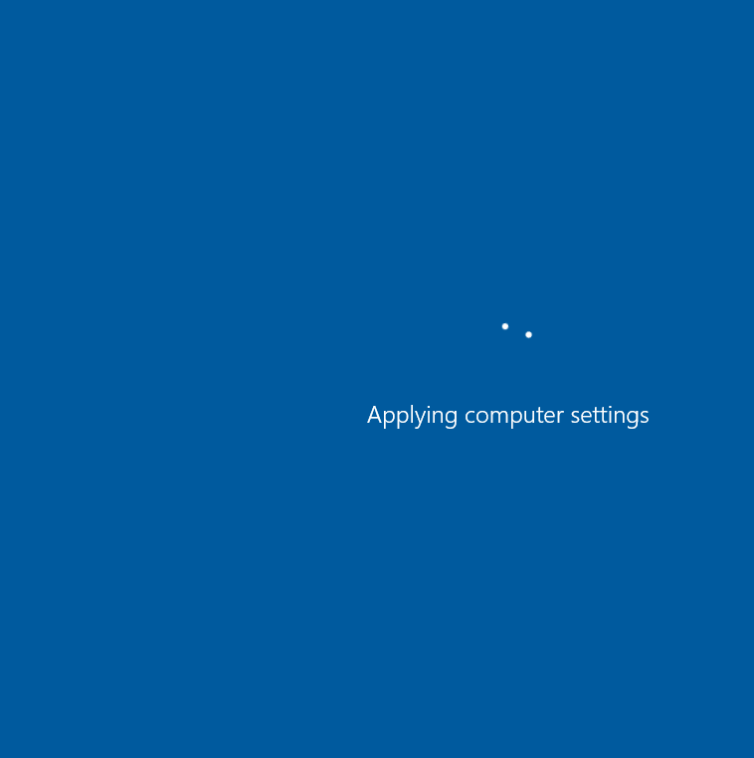

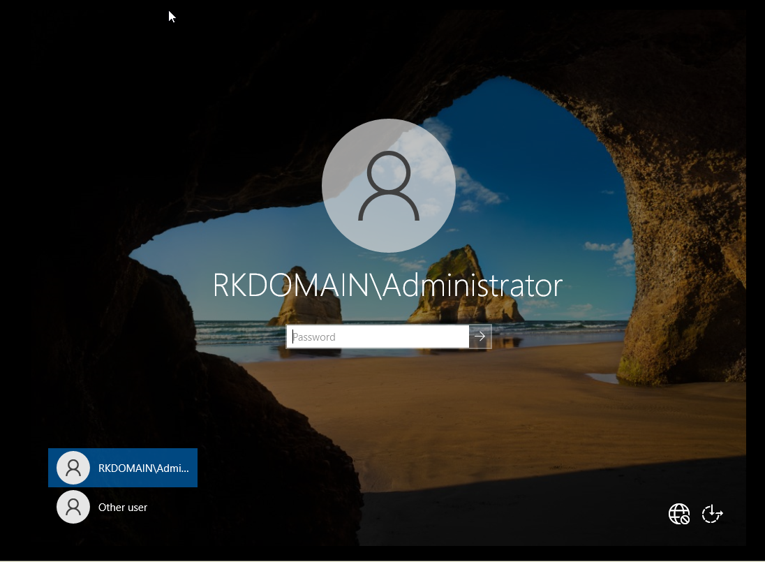

***Step 6: Create a Domain Admin User***

I created a highly privileged user account with the following details:

* Username: Rosemarie Kpaka
* Group Membership: Added to the Domain Admins group.
* Security: A strong password was set.

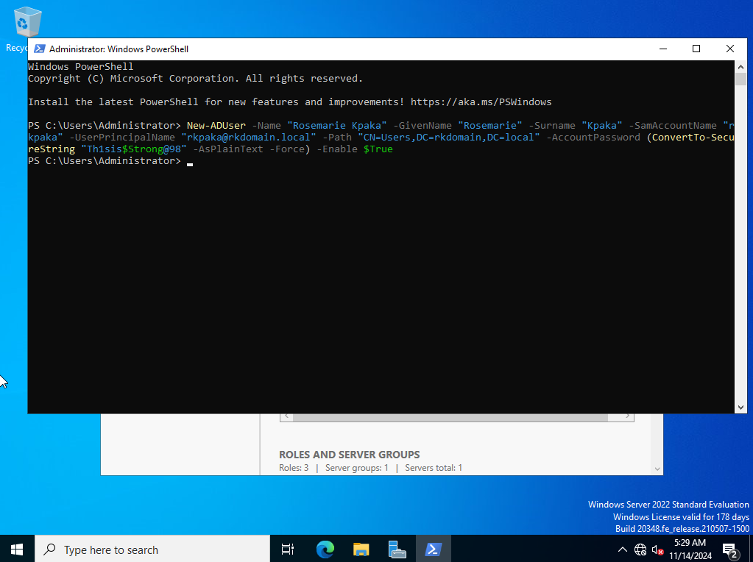

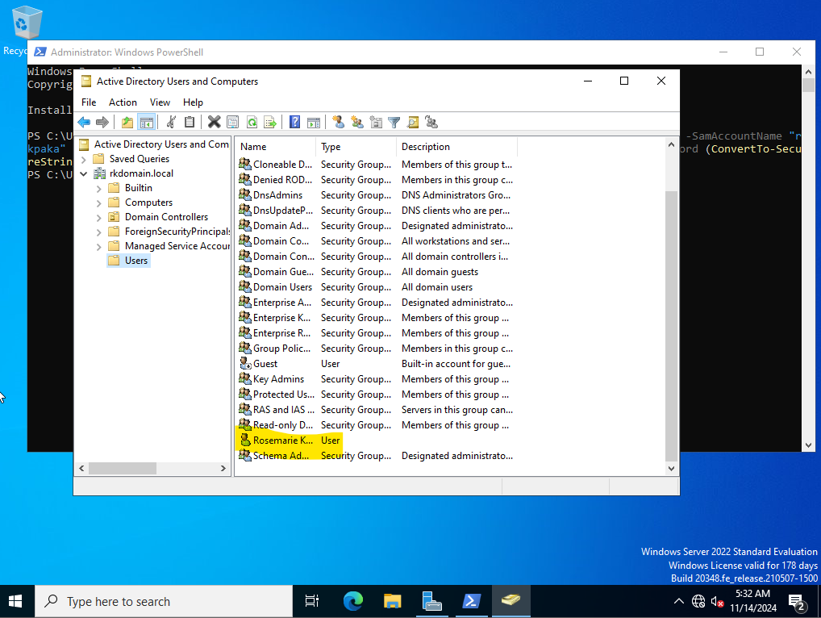

***Step 7: Enable Active Directory Recycle Bin***

I enabled the Active Directory Recycle Bin to restore deleted AD objects.

Process:

* Used Active Directory Administrative Center and enabled the Recycle Bin from Manage > Enable Recycle Bin.

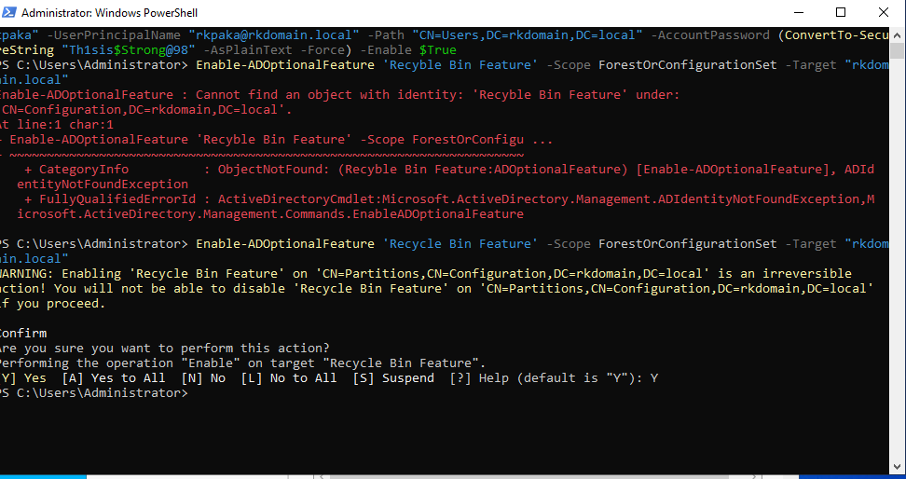

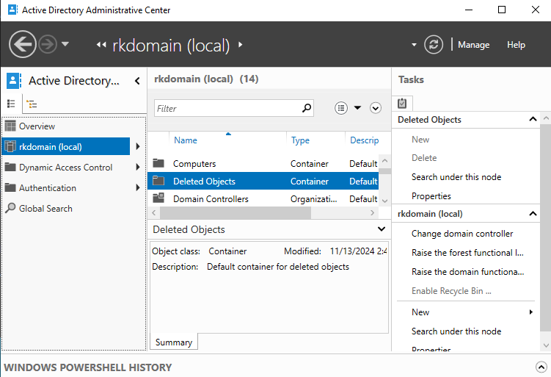

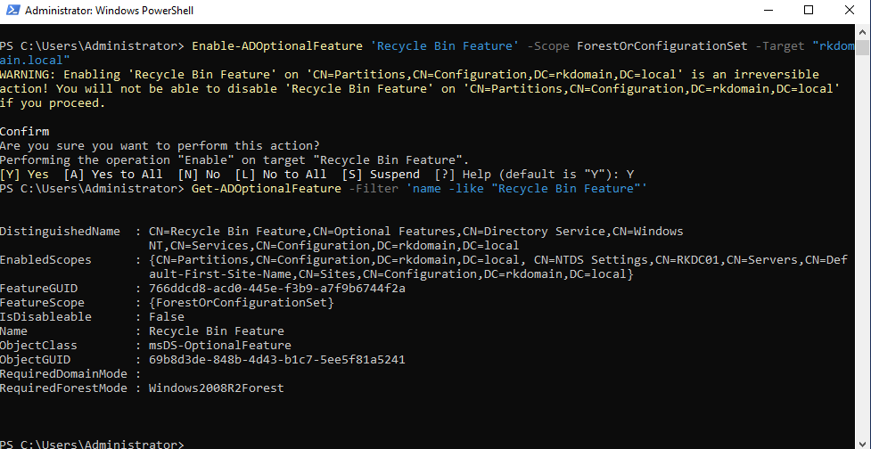

***Step 8: Configure DC02 as Secondary Domain Controller***

To establish redundancy, I configured DC02 as a secondary domain controller and confirmed replication with DC01.

Process:

* Replicated steps in Step 5 to add DC02 to the rkdomain.local domain.

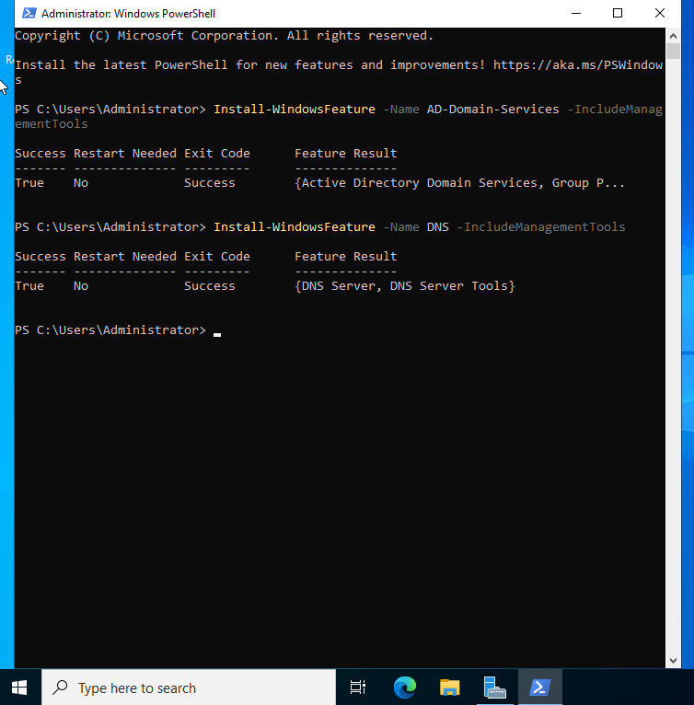

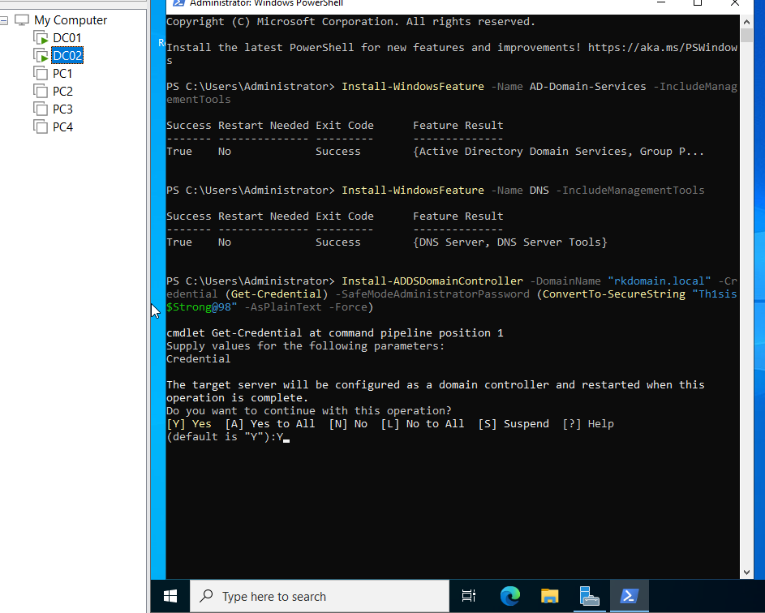

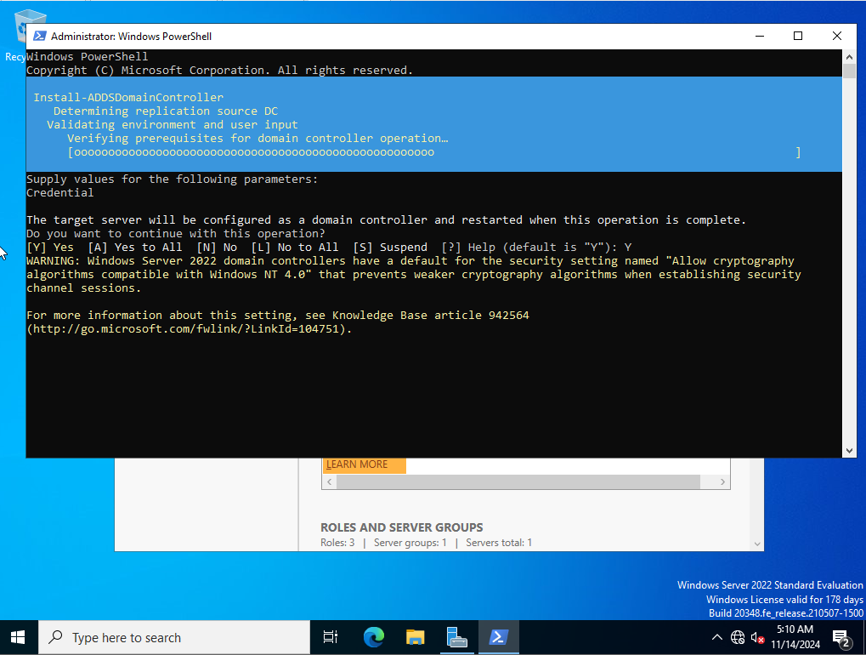

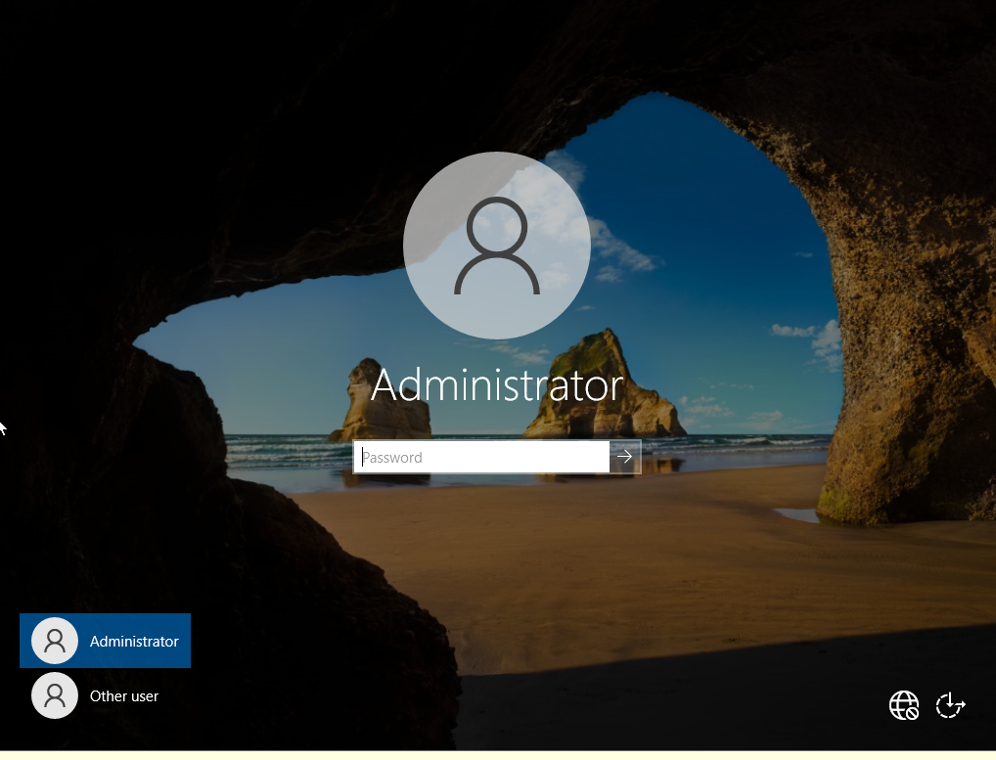

***Step 9: Patch DC02***

I repeated the patching process on DC02 using the same PowerShell commands as in Step 2.

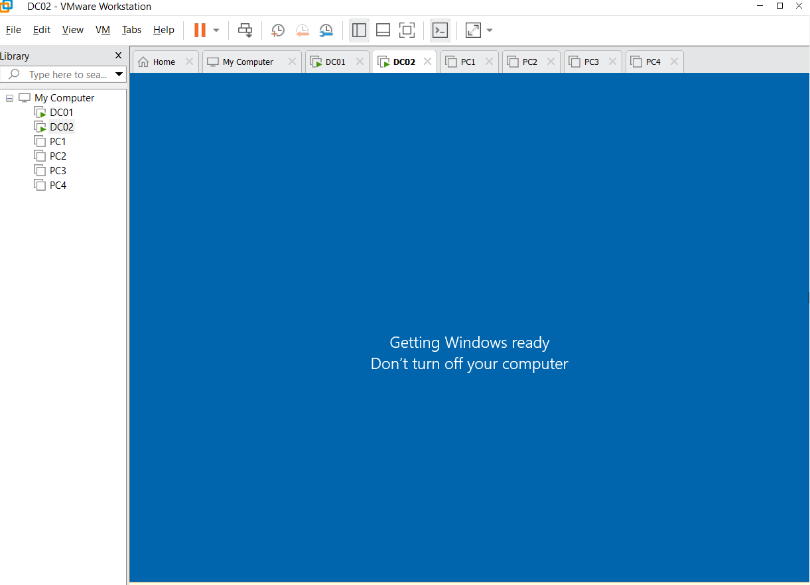

***Step 10: Create InitialConfig Checkpoints***

I created checkpoints for both DC01 and DC02 to capture the initial configuration state.

Process:

Using Hyper-V Manager, created a checkpoint named “InitialConfig” for each VM.

***Step 11: Join Additional VMs to the Domain***

I joined the remaining VMs to the domain and renamed them using the initials format.

VM Names:

* PC1: RKPC1,
* PC2: RKPC2,
* PC3: RKPC3, and
* PC4: RKPC4.

Process:

* Changed hostnames and added each VM to the domain rkdomain.local.

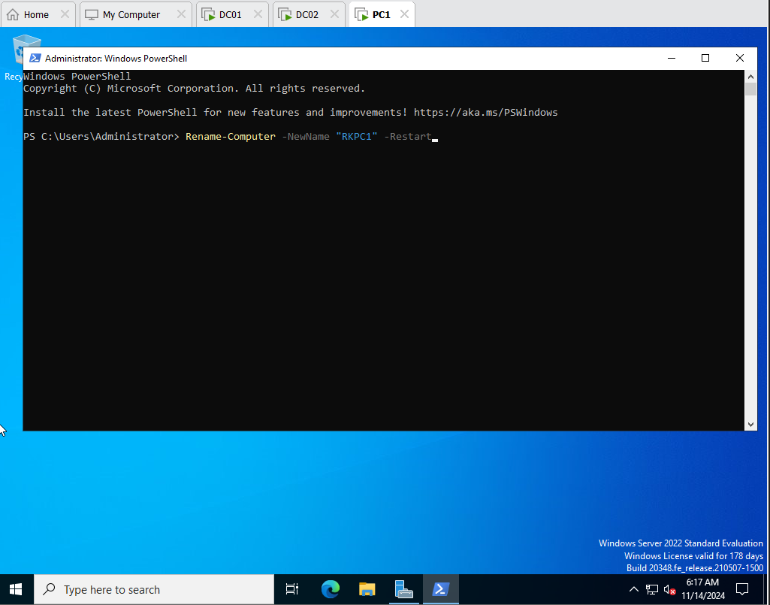

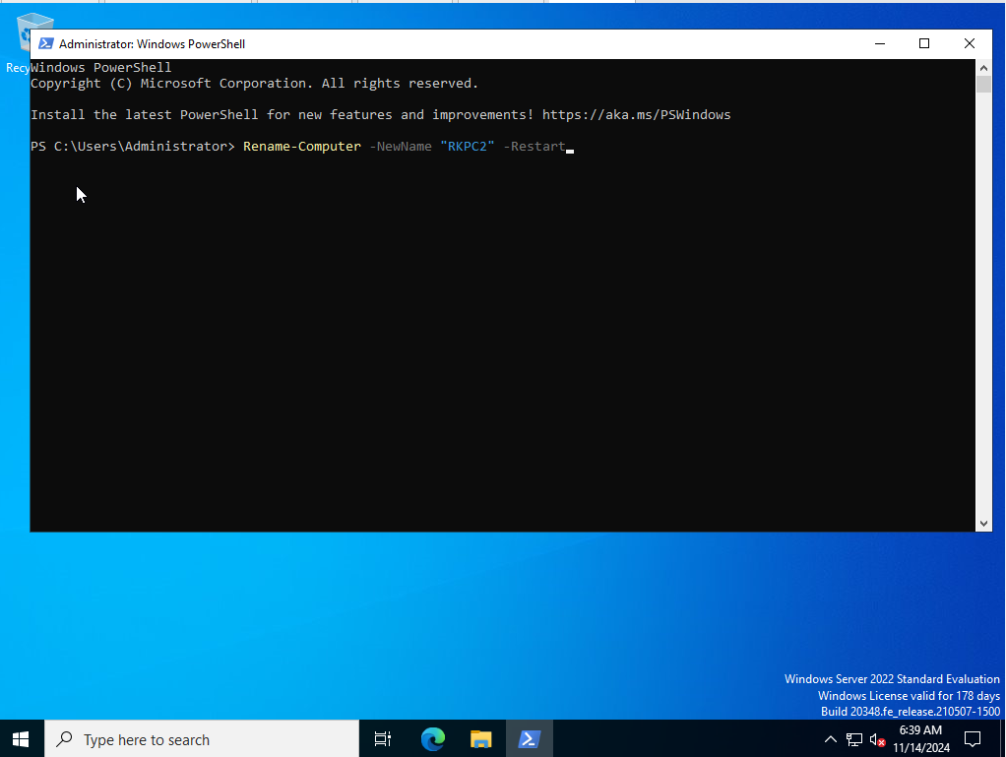

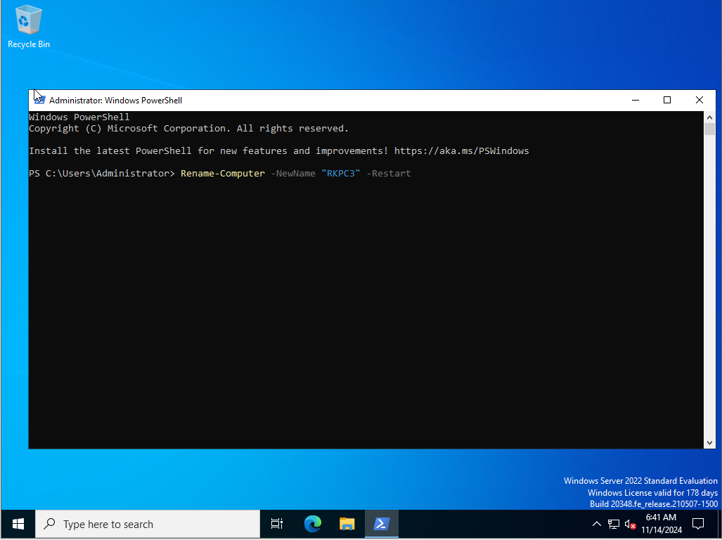

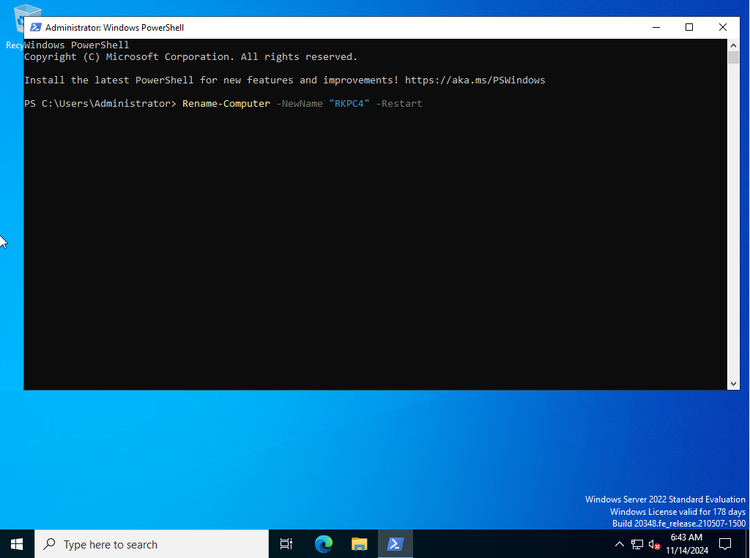

**Testing and Verification**

I verified the setup by logging into a domain user account and confirming that DC01 and DC02 were synchronized.

Testing Performed:

* Logged in with the new Domain Admin user.
* Confirmed replication and synchronization between DC01 and DC02.

**Conclusion**

This project demonstrated a successful setup of an on-premises Active Directory environment, which centralizes management, enhances security, and improves resource sharing across a network. Through this setup, I learned the significance of AD DS in enterprise settings and gained experience in configuring domain controllers, applying security patches, and managing Active Directory components. The project provided hands-on exposure to server administration and enterprise-level IT infrastructure.